This article has two major parts. In the first part we will discuss about 3.Tier Architecture and in the second part we will implement an ASP.NET example to practice the 3.Tier design. You need the Visual Studio.net with c# compiler, IIS and a Microsoft SQL Server to follow this article.
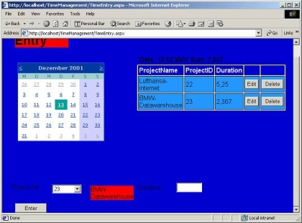
Fig 0 : (TimeEntry.aspx)
Contents
1. 3.Tier Architecture
1.0 Definition and Motivation.02
1.1 Data Tier,,,04
1.2 Logical Tier ..04
1.2.1 Business Tier.05
1.2.2 Data Access Tier........05
1.3 Presentation Tier....05
2. Creating a 3.Tier ASP.NET application
2.1 Installing the web application TimeManagement..05
2.2 Implementing of Data Tier....07
2.2.1 Table Person...07
2.2.2 Table ProjectI.08
2.2.3 Table ProjectInvolvement.08
2.3 Implementing Logical Tier....10
2.3.1 Implementing Data Access Tier.10
2.3.2 Implementing Business Tier........ 18
2.4 Implementing Presentation Tier.....20
2.5 Conclusion..23
2.6 Reference...23
1. 3-Tier Architecture
1.0 Definition and motivation
A 3-tier application is a program which is organized into three major disjunctive tiers. These tiers are
- Presentation Tier (Front end)
- Logical Tier (Middleware)
- Data Tier (Backend).
Each layer can be deployed in geographically separated computers in a network. Some architects divide Logic Tier in to two sub tiers Business and Data Access Tiers, in order to increase scalability and transparency. The tiers can be deployed on physically separated machines. The characteristic of the tier communication is that the tiers will communicate only to their adjacent neighbors. For an example, The Presentation Tier will interact directly with the Business Tier and not directly with Data Access or Data Tiers. 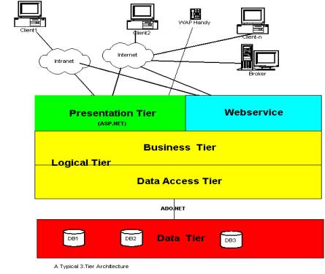
Fig 1 (A typical 3.Tier Architecture)
The Figure 1 shows a typical 3.Tier Architecture scenario. I think, we should look back the history of computing to understand the advantages of 3.Tier Architecture.
Mainframes ruled the it-landscape until mid 1980s .The main characteristic of a Host Architecture is that the application and databases reside on the same host computer and the user interact with the host using an unfriendly and dump terminal. This monolith architecture does not support distributed computing (the host applications are not able to connect a database of a strategically allied partner). Some mangers found that developing a host application take too long and expensive. Consequently led these disadvantages to Client-Server(C/S) architecture.
In fact, Client Server(C/S) architecture is a 2-Tier architecture because the client does not distinguish between Presentation Tier and Logical Tier. That is why we call this type of client as Fat Client. The increasing demands on GUI controls caused difficulty to manage the mixture of source code from GUI and Business Logic (Spaghetti Code). Further, C\S Architecture does not support enough the Change Management. Let us suppose that the government increases the consume tax rate from 14% to 16 %, then in the C\S case, you have to send an update to each clients and they must update synchronously on a specific time otherwise you may store corrupt information. The C/S Architecture is also a burden to network traffic and resources. Let us assume that about five hundred clients are working on a data server then we will have five hundred ODBC connections and several ruffian record sets, which must be transported from the server to the clients (because the Business Logic Tier is situated in the client side). The fact that C/S does not have any caching facilities like in ASP.NET, caused additional traffic in the network. In the late 1990s, designers have shifted the Business Logic from the client to server to elude the handicaps from C/S Architecture. Normally, a server has a better hardware than client therefore it is able compute algorithms faster than a client, so this fact is also an additional pro argument for the 3.Tier Architecture.
Now let us go back to our 3.Tier Architecture and start to explore the tiers.
1.1 Data Tier
This Tier is responsible for retrieving, storing and updating from Information therefore this tier can be ideally represented through a commercial database. We consider stored procedures as a part of the Data Tier. Usage of stored procedures increases the performance and code transparency of an application
1.2 Logical Tier
This is the brain of the 3.Tier Application. Some architects do not make any distinction between Business Tier and Data Access Tier. Their main argumentation is that additional tiers will screw down performance. I think that we will have more advantages, if we separate Logical Tier in to Business Tier and Data Access Tier. Some of these advantages are
- Increases code transparency
- Supports changes in Data Layer. You can change or alter database with out touching the Business Layer and this would be a very minimum touch up.
1.2.1 Business Tier
This sub tier contents classes to calculate aggregated values such like total revenue, cash flow and ebit and this tier doesnt know about any GUI controls and how to access databases. The classes of Data Access Tier will supply the needy information from the databases to this sub tier.
1.2.2 Data Access Tier:
This tier acts as an interface to Data Tier. This tier knows, how to (from which database) retrieve and store information.
1.3 Presentation Tier:
This Tier is responsible for communication with the users and web service consumers and it will use objects from Business Layer to response GUI raised events.
After this brief theory, I think we should move now to the practical part. Our aim is to develop a work diary for employees, in which they can record daily project activities.
2. Creating a 3.Tier ASP.NET application.
You need a SqlServer, IIS and Microsoft.NET CLR to run the example application. Please follow the steps to run the ASP.NET application.
2.1 Installing the web application Timemanagement
You should follow these steps to install the web application TimeManagement on your machine.
- Create a new Sql Server database with the name TimeManagement and execute the file TimeManagement.sql (included the Zip file) by using the tool SQL Query Analyzer to create the needed tables and store procedures for this application.
- Create an ASP.Net Appliaction TimeManagement and replace it with the file TimeManagement which you find in the .zip file
- Adjust the XML Element <appsettings> in the Web.config file to establish SQL connection.(modify the value from Sqlconnection)
<appSettings>
<addkey="SqlConnect" value="server=F5;database=TimeManagement;uid=sa;pwd=moses;" />
</appSettings>
- Set the Page LogIn.aspx as the start page.
I hope now that you can run the web application
2.2 Implementing of Data Tier
This tier is represented by the Sqlserver database TimeManagement and it has 3 tables. The Fig 2 shows the ERD diagram of the database TimeManagement. Now, I like to describe the tables briefly.
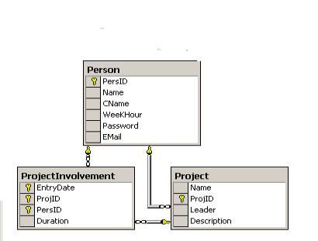
Fig 2
2.2.1 Table Person
This table stores information about employees. The attribute PersID is the primary key of this table and the database will increment this value automatically during insertion of a new data row. The values of the attribute Email correspond bijectively to the values of the attribute PersID. In order to obtain this relationship, application must keep the values of attribute Email unique. We have implemented this rule in the stored procedure InsertPerson (see fig 3), which is used to insert a new record.
CREATE PROCEDURE InsertPerson
(
@Name char(50),
@CName char(50),
@WeekHour int,
@Passwordchar(50),
@EMail char(50),
@AlreadyIn int out
)
AS
SELECT @AlreadyIn=COUNT(*) FROM Person WHERE EMail=@EMail
IF @AlreadyIn=0
INSERT INTO Person
(Name ,CName ,WeekHour ,Password ,EMail )
VALUES
(@Name ,@CName ,@WeekHour ,@Password ,@EMail )
GO
Fig 3
2.2.2 Table Project
This table stores information about projects of a firm. The attribute ProjID is the key of this table and it will be automatically incremented by the database during the insertion a new row. The attribute Leader is a foreign key of the table Person.
2.2.3 Table ProjectInvolvement
This table contents information to answer questions such like: how many hours has spent employee X in the project P on a specific day?. The key attributes of this table are EntryDate ,ProjID and PersID. The attribute ProjID is a foreign key of the Table Project and the attribute is PersID is a foreign key of the table Person.
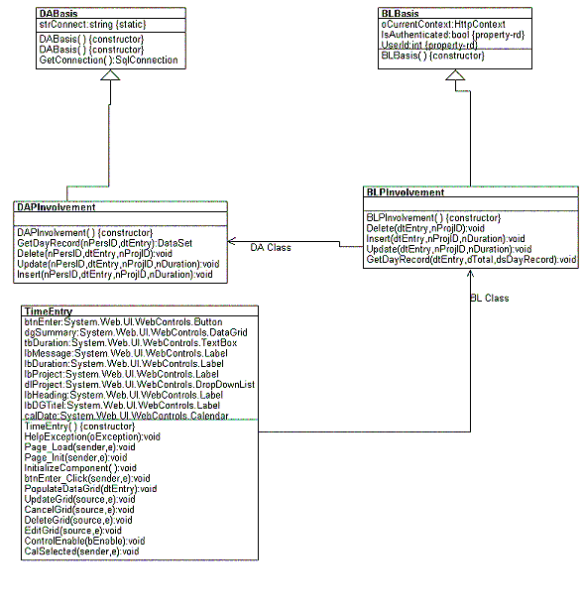
Fig 4 ( partial class diagram of the application TimeManagement)
2.3 Implementing Logical Tier
2.3.1 Implementing Data Access Tier
All classes of Data Access Tier are derived from the super class DABasis(See Fig 4), which is responsible for establishing database connection.
<appSettings>
<addkey="SqlConnect" value="server=F5;database=TimeManagement;uid=sa;pwd=moses;" />
</appSettings>
Fig 5 (partial source code from Web.config)
/// <summary>
/// This is the super class for Data Access Classes
/// </summary>
class DABasis
{
protected static string strConnect;
public DABasis()
{
}
/// <summary>
/// Please see the web.config file
/// </summary>
static DABasis()
{
strConnect=ConfigurationSettings.AppSettings["SqlConnect"];
}
/// <summary>
/// Gets a SqlConnection to the local sqlserver
/// </summary>
/// <returns>SqlConnection</returns>
protected SqlConnection GetConnection()
{
SqlConnection oConnection = new SqlConnection(strConnect);
return oConnection;
}
}
Fig 6 (class DABasis)
We have stored the global application attributes such like string SqlConnect in the configuration file Web.config and you can retrieve this value using the sealed class ConfigurationSettings (See Fig 6: static DABasis()).
We like to show you now exemplary typical data access methods of a DataAccess class, which are used retrive a Dataset or insert or update some data rows. In our implementation we distinguish two types Data Access methods and they are:
- Query Data Access Method: which are used typically to retrieve data structures like DataSet or DataTable from tables.
- Non Query Data Access Method: which are used typically to update a table or insert a data row in to a table.
At first, we going to look a Query Data Access Method.The class DAPInvolvement wraps a bundle of data access methods which deal with the matter project involvement. The method void Dataset DAPInvolvement.GetDayRecord(int nPersID,DateTime dtEntry) (see Figure 8) will return a dataset, which contents all project activities of a person with the ID PersID on a particular day dtEntry This method uses the stored procedure GetDayRecord (see Fig 7) to retrieve essential data from the tables ProjectInvolvement and Project.
CREATE PROCEDURE GetDayRecord
(
@PersID int,
@EntryDate datetime
)
AS
SELECT P.Name, P.ProjID, PI.Duration
FROM ProjectInvolvement PI , Project P
WHERE PI.PersID= @PersID and PI.ProjID=P.ProjID and PI.EntryDate=@EntryDate
Fig 7 (Store Procedure GetDayRecord)
/// <sumary>
/// gives the list of activities of the (person)ID for the particular EntryDate
/// </summary>
/// <param name="nPersID">PersID attribute of ProjectInvolvement</param>
/// <param name="dtEntry">EntryDate attribute of ProjectInvolvement</param>
/// <returns>DataSet and the table name is "dtDayRecord" </returns>
public DataSet GetDayRecord(int nPersID,DateTime dtEntry)
{
SqlConnection oConnection = GetConnection();
// build the command
SqlCommand oCommand = new SqlCommand("GetDayRecord",oConnection);
oCommand.CommandType=CommandType.StoredProcedure; // Parametrs
SqlParameter paraPersID= new SqlParameter("@PersID",SqlDbType.Int,4);
paraPersID.Value=nPersID;
oCommand.Parameters.Add(paraPersID);
SqlParameter paraEntryDate=
new SqlParameter("@EntryDate",SqlDbType.DateTime);
paraEntryDate.Value=dtEntry;
oCommand.Parameters.Add(paraEntryDate);
// Adapter and DataSet
SqlDataAdapter oAdapter= new SqlDataAdapter();
oAdapter.SelectCommand=oCommand;
DataSet oDataSet = new DataSet();
try
{
oConnection.Open();
oAdapter.Fill(oDataSet,"dtDayRecord");return oDataSet;
}
catch(Exception oException){
throw oException;
}
finally
{
oConnection.Close();
}
}
Fig 8 (The method DAPInvolvement.GetDayRecord)
A typical Query Data Access method might be abstractly described like this:
- Establish SqlConnection.
- Create a SqlCommand and necessary SqlParameters to the command.
- Create a DataSet and a SqlDataAdapter.
- Open the connection and fill the DataSet with help of the SqlDataAdapter.
- Close the SqlConnection.
Some of you may ask the question, why we are using a DataSet instead a SqlDataReader. Indeed , you can retrieve data rows faster using a SqlDataReader than a Dataset, but if you want use WebService, you ought to use DataSet. Because it is not possible to transmit a SqlDataReader using SOAP protocol. You can transmit via SOAP all objects which are belong to the types:
- DataSet (ADO.NET)
- Complex Arrays
- XML nodes
Now, I want to show a typical Non Query Data Access method. The DataAccess method:
public void DAProject.Insert(string strName,string strDescription,int nLeader,out int nAlreadyIn)
(see Figure 10) is used to insert a new project in to the database and it uses the stored procedure InsertProject.
(see Fig 9). The out parameter of this method out int nAlreadyIn serves as a flag to the classes of Business Logic Tier, whether the record is inserted by this method or not.
CREATE PROCEDURE InsertProject
(
@Name char(50),
@Description char(150),
@Leader int,
@AlreadyIn int output
)
AS
SELECT @AlreadyIn = Count(*) From Project WHERE Name=@Name
IF @AlreadyIn =0
INSERT INTO Project
(Name,Description,Leader)
VALUES
(@Name,@Description,@Leader)
GO
Fig 9 (store procedure InsertProject)
/// <summary>
/// inserts a new data row into the table "project"
/// </summary>
/// <param name="Name"></param>
/// <param name="Description"></param>/// <param name="Leader">a foreign key
from Person</param>
/// <param name="AlreadyIn">number of records which fulfill the term "Name=strName"
efore the Insertation</param>
public void Insert(string strName,string strDescription,int nLeader,
out int nAlreadyIn)
{
// Establish Connection
SqlConnection oConnection = GetConnection();
// build the command
SqlCommand oCommand = new SqlCommand("InsertProject",oConnection);
oCommand.CommandType=CommandType.StoredProcedure;
// Parameters
SqlParameter paraName= new SqlParameter("@Name",SqlDbType.Char,50);
paraName.Value=strName;
oCommand.Parameters.Add(paraName);
SqlParameter paraDescription= new SqlParameter("@Description",SqlDbType.Char,150);
paraDescription.Value=strDescription; oCommand.Parameters.Add(paraDescription);
SqlParameter paraLeader = new SqlParameter("@Leader",SqlDbType.Int);paraLeader.Value=nLeader;
oCommand.Parameters.Add(paraLeader);
SqlParameter paraAlreadyIn = newSqlParameter("@AlreadyIn",SqlDbType.Int);
paraAlreadyIn.Direction=ParameterDirection.Output;
oCommand.Parameters.Add(paraAlreadyIn);
try
{
oConnection.Open();
oCommand.ExecuteNonQuery();
nAlreadyIn=(int) paraAlreadyIn.Value;
}
catch(Exception oException){
throw oException;}
finally
{
oConnection.Close();
}
}
Fig 10 (Method DAProject.Insert)
A typical Non Query Data Access method might be described abstractly like this:
(see Fig 10)
- Establish SqlConnection.
- Create a SqlCommand and the SqlParameters to the command.
- Open the connection and execute the query.
- Retrieve the values from all output parameters.
- Close the SqlConnection.
public class BLBasis
{
// Current HttpContext
protected HttpContext oCurrentContext;
public BLBasis()
{
oCurrentContext= HttpContext.Current;
}
/// <summary>
/// returns true, if the web client authorized or not
/// </summary>
public bool IsAuthenticated
{
get
{
return oCurrentContext.User.Identity.IsAuthenticated;
}
}
/// <summary>
/// returns the UserID,if the user already authorized
/// </summary>
public int UserId
{
get
{
if(IsAuthenticated)
{
string strHelp=oCurrentContext.User.Identity.Name;
return Int32.Parse(strHelp);
}else
{
return -1;
}
}
}
}
Fig 11 (class BLBasis)
2.3.2 Implementing Business Tier
All classes of Business Tier have the super class BLBasis (Fig 11) and it will supply its derived classes session relevant informations such like UserID . The web application uses the attribute UserID to identify the current user. We use the method public static void FormsAuthentication . Redirect-FromLoginPage( string userName, bool createPersistentCookie) to assign the user identity in to the current instance of the HttpContext class.
Now, let us analyze a class of this tier in order to understand the pattern. The class BLPInvolvement is a Business Logic class and gathers all interrelated methods, which deal with the topic project involvement. The method public void BLPInvolvement.GetDayRecord(DateTime dtEntry,out double dTotal out DataSet dsDayRecord) (see Fig 12) is responsible to pass a Dataset and a numeric value to the Presentation Layer.
Fig 12 ( class BLPInvolvement)
A typical Business Logic method might abstractly described like this:
- Instantiate an Data Access object
- Retrieve the crude data.
- Calculate business values from the crude data.
2.4 Implementing Presentation Tier
We have used ASP.NET to implement the Presentation Layer and now we like to show you exemplarily , how the Presentation Layer communicates with the Data Access Layer. The Figure 0 shows the web side TimeEntry.aspx, where an employee can record his project activities for a certain day. The method private void TimeEntry.btnEnter_Click(object sender, System.EventArgs e) is a callback method, which will be activated, if the user pushes the enter button.
/// <summary>
/// this method populates datagrid dgSummary
/// </summary>
void PopulateDataGrid(DateTime dtEntry)
{
try
{
// retrive DataSet and bind to the datagrid
BLPInvolvement oBLPInvolvement = new BLPInvolvement();
DataSet oDataSet;
double dTotalDuration;
oBLPInvolvement.GetDayRecord(dtEntry,out dTotalDuration,out oDataSet);
DataTable dtDayRecord=oDataSet.Tables["dtDayRecord"];
if(dtDayRecord.Rows.Count>0)
{
dgSummary.DataSource=dtDayRecord;
dgSummary.DataBind();
lbDGTitel.Text="Date: "+dtEntry.ToShortDateString()
+" Sum: "+dTotalDuration.ToString();
}
else
{
dgSummary.DataSource=null;dgSummary.DataBind();
lbDGTitel.Text="No Records found";
}
}
catch(Exception oException)
{
this.HelpException(oException);
}
}
/// <summary>/// It is used publish exception text
/// </summary>
/// <param name="oException"></param>
private void HelpException(Exception oException)
{
if(lbMessage.Text!="")
{
lbMessage.Text+=oException.Message;
}
else
lbMessage.Text=oException.Message;
}
Fig 12 (Extract from the class TimeEntry)
The Figure 12 shows a partial source code, which is responsible for inserting a new project involvement record. The method takes following steps to accomplish the Task:
- Draw off the values from GUI controls.
- Instantiate an object from the Class BLPInvolvement and insert it in to the database.
- Update the other involved GUI controls.
- Publish the error message , if an error occurred in the Logic Tier or in Data Tier.
2.5 Conclusion
If we look back implementation phase, we can say that it is quite simple to build a 3-Tier Architecture using Microsoft.NET. I think the following tips are useful to increase transparency and stability of the system:
- Follow the adjacent rule (Dont jump over a neighbor tier ,because it makes us easy to follow systematically from the button click to database access).
- Use Web.config file to define global values.
- Use try, catch and finally control structures in every tier to track bugs.

}
}
catch(Exception oException)
{
this.HelpException(oException);
}
}
/// <summary>/// It is used publish exception text
/// </summary>
/// <param name="oException"></param>
private void HelpException(Exception oException)
{
if(lbMessage.Text!="")
{
lbMessage.Text+=oException.Message;
}
else
lbMessage.Text=oException.Message;
}
Fig 12 (Extract from the class TimeEntry)
The Figure 12 shows a partial source code, which is responsible for inserting a new project involvement record. The method takes following steps to accomplish the Task:
- Draw off the values from GUI controls.
- Instantiate an object from the Class BLPInvolvement and insert it in to the database.
- Update the other involved GUI controls.
- Publish the error message , if an error occurred in the Logic Tier or in Data Tier.
2.5 Conclusion
If we look back implementation phase, we can say that it is quite simple to build a 3-Tier Architecture using Microsoft.NET. I think the following tips are useful to increase transparency and stability of the system:
- Follow the adjacent rule (Dont jump over a neighbor tier ,because it makes us easy to follow systematically from the button click to database access).
- Use Web.config file to define global values.
- Use try, catch and finally control structures in every tier to track bugs.
2.6 Reference

